**BIS 698 - Information Systems**

**Master of Science in Information Systems**

**Vehicle Service & Maintenance Management System**

**Client – BookMyRepair**

**Date- 13/30/2025**

**Submitted by**

**Group – 5**

**Jeo Yesudas**

**Vamshi kurra**

**Hareesh Payankalodath**

**Nimilitha Narayani Sadaram**

**Manisha Reddy Chinthalapani**



# Use Case Diagrams

* 1. **User Registration**

|  |
| --- |
| **Use Case Name:** User Registration **ID:** UC-1 **Priority:** High |
| **Actor:** Customer |
| **Description:** Allows customers to register and access the system. |
| **Trigger:** A new user wants to register an account**.** |
| **Type:** External |
| **Preconditions:**   1. **The system is accessible online.** |
| **Normal Course:**   1. The user navigates to the registration page. 2. The user fills in the registration form with name, email, and password. 3. The user submits the form. 4. The system validates the email. a. If the email is unique, the system creates an account. b. If the email exists, an error message is displayed. 5. The system stores user data. 6. The system confirms registration. |
| **Postcondition:**   1. The new user is registered. 2. The user is eligible to log in. |

**1.2 User Login**

|  |
| --- |
| **Use Case Name:** User Login **ID:** UC-2 **Priority:** High |
| **Actor:** Customer, Admin, Mechanic |
| **Description:** Allows users to log in to the system. |
| **Trigger:** A user attempts to access their account. |
| **Type:** External |
| **Preconditions:**   1. The user must be registered. |
| **Normal Course:**   1. The user navigates to the login page. 2. The user enters login credentials. 3. The system validates the credentials. 4. If correct, access is granted. 5. The user is directed to their dashboard 6. If incorrect, an error message is displayed. |
| **Postcondition:**   1. The user accesses their account. 2. The system logs the user session. |

**1.3 Service Booking**

|  |
| --- |
| **Use Case Name:** Book a Service **ID:** UC-3 **Priority:** High |
| **Actor:** Customer |
| **Description:** Customers can book a mechanical service. |
| **Trigger:** A user wants to book a service. |
| **Type:** External |
| **Preconditions:**   1. The user must be logged in. |
| **Normal Course:**   1. The user searches for available mechanics by ZIP code. 2. The user selects a mechanic and service type. 3. The user selects Home Service or Workshop Visit. 4. The user confirms booking. 5. The system updates the mechanic’s schedule and stores booking details. 6. The system sends booking confirmation |
| **Postcondition:**   1. The service is booked successfully. 2. Notification will be sent to the customer |

**1.4 Mechanic Registration**

|  |
| --- |
| **Use Case Name:** Mechanic Registration **ID:** UC-4 **Priority:** High |
| **Actor:** Mechanic |
| **Description:** Customers can book a mechanical service. |
| **Trigger:** A user wants to book a service. |
| **Type:** External |
| **Preconditions:**   1. The mechanic must have valid business details |
| **Normal Course:**   1. The mechanic fills out a registration form. 2. The mechanic submits the registration request. 3. The system validates details and stores them. 4. Admin reviews and approves or rejects the request. 5. Upon approval, the mechanic account is activated. |
| **Postcondition:**   1. The service is booked successfully. 2. Notification will be sent to the customer |

**1.5 Report Generation**

|  |
| --- |
| **Use Case Name:** Generate Report **ID:** UC-5 **Priority:** High |
| **Actor:** System |
| **Description:** Customers can book a mechanical service. |
| **Trigger:** A user wants to book a service. |
| **Type:** External |
| **Preconditions:**   1. At least one service booking must be completed |
| **Normal Course:**   1. The system identifies a completed service. 2. The system generates a PDF with booking details. 3. The system sends the report to the admin |
| **Postcondition:**   1. The report is successfully generated and sent. 2. The admin will have complete booking details. |

**2.Process Model with DFD**

**Context Diagram**

**Entities and Data Stores:**

**1. User (Customer)**

* The **main actor** who interacts with the system to **register, book a mechanic, and track appointments**.
* Customers can **view available mechanics**, **choose services**, and **receive appointment confirmations**.

**2. Mechanic (Service Provider)**

* The mechanic provides repair services and interacts with the system by accepting bookings, updating service status, and confirming appointments.
* Mechanics must register their business and get admin approval before they can receive bookings.

**3. Admin**

* The admin is responsible for approving mechanics, managing services, and monitoring the overall system performance.
* The admin also processes reports and ensures mechanics comply with system requirements.

**4. Data Stores (System Databases)**

* **D1: User Data Store** – Stores customer registration and login credentials.
* **D2: Appointment Data Store** – Stores booking details, appointment dates, and statuses.
* **D3: Service Data Store** – Stores available repair services and pricing.
* **D4: Mechanic Data Store** – Stores mechanic profiles, availability, and approvals.

**Processes and Their Functions:**

**1.0 User Registration**

* **Purpose:** Allows customers to create an account to book services.
* **Input:** Customer enters name, email, password to sign up.
* **Process:**
  1. The user accesses the registration page.
  2. The system validates user details (checks if the email already exists).
  3. If validation is successful, the system stores the user’s details in D1: User Data Store.
* **Output:**
  1. If the registration is successful, the user can log in and proceed with booking services.
  2. If registration fails (e.g., duplicate email), the user receives an error message.

**2.0 Book Appointment**

* **Purpose:** Allows customers to book a vehicle service with a mechanic.
* **Input:** Customer selects a service and mechanic.
* **Process:**
  1. The user logs in and searches for mechanics based on ZIP code.
  2. The system fetches available mechanics from D4: Mechanic Data Store.
  3. The system retrieves service details from D3: Service Data Store (service types, costs, estimated time).
  4. The user selects a mechanic and chooses service mode (Home Service or Workshop Visit).
  5. The system stores the booking in D2: Appointment Data Store and sends a confirmation to the customer and mechanic.
* **Output:**
  1. Customers receive booking confirmation and estimated repair time.
  2. Mechanics get notified about new service requests.

**3.0 Provides Resources (Mechanic Management)**

* **Purpose:** Ensures mechanics are registered, approved, and assigned bookings.
* **Input:** Mechanics request to register their business.
* **Process:**
  1. Mechanics fill out a registration form.
  2. The system validates mechanic details and stores them in D4: Mechanic Data Store.
  3. The admin reviews the registration request and either approves or rejects the mechanic.
  4. If approved, the mechanic profile becomes active, and they start receiving bookings.
  5. When a customer books an appointment, the system fetches mechanic details from D4: Mechanic Data Store to match them with the correct service.
* **Output:**
  1. Mechanics receive a confirmation of approval.
  2. Admin receives pending registration requests for verification.
  3. Customers can now view and book approved mechanics.

**4.0 Service Management**

* **Purpose:** The admin manages mechanic approvals, service requests, and system **reports**.
* **Input:** The admin processes mechanic approval requests and service data.
* **Process:**
  1. The admin receives mechanic approval requests and verifies their credentials.
  2. If approved, the mechanic is added to the system and can receive service bookings.
  3. The admin monitors services and bookings, making sure the system functions properly.
  4. The system generates reports for the admin, summarizing appointments, user activity, and mechanics’ performance.
* **Output:**
  1. Approved mechanics get access to customer bookings.
  2. Admins receive reports on system performance and service requests.

**Data Flows in the System**

1. **Customer Registration:** Data is stored in D1 (User Data Store).
2. **Booking an Appointment:** The system fetches service details from D3 (Service Data Store), matches a mechanic from D4 (Mechanic Data Store), and stores the appointment in D2 (Appointment Data Store).
3. **Mechanic Approval:** The admin validates mechanic requests and updates D4 (Mechanic Data Store).
4. **Appointment Confirmation:** Customers and mechanics receive notifications about service status updates.

## **3.Task List**

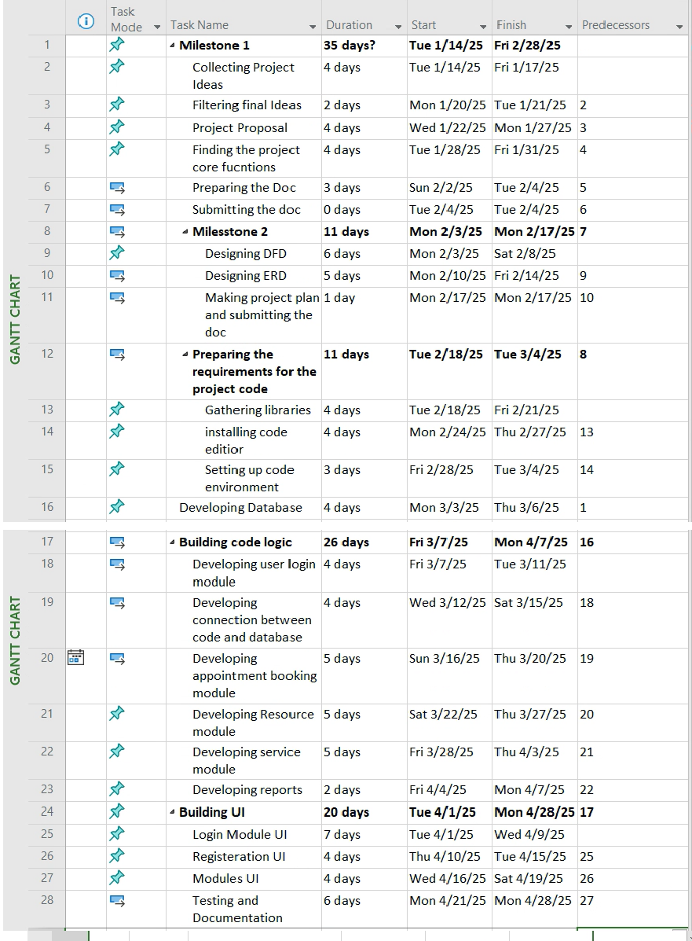

## **4.Critical Path**

